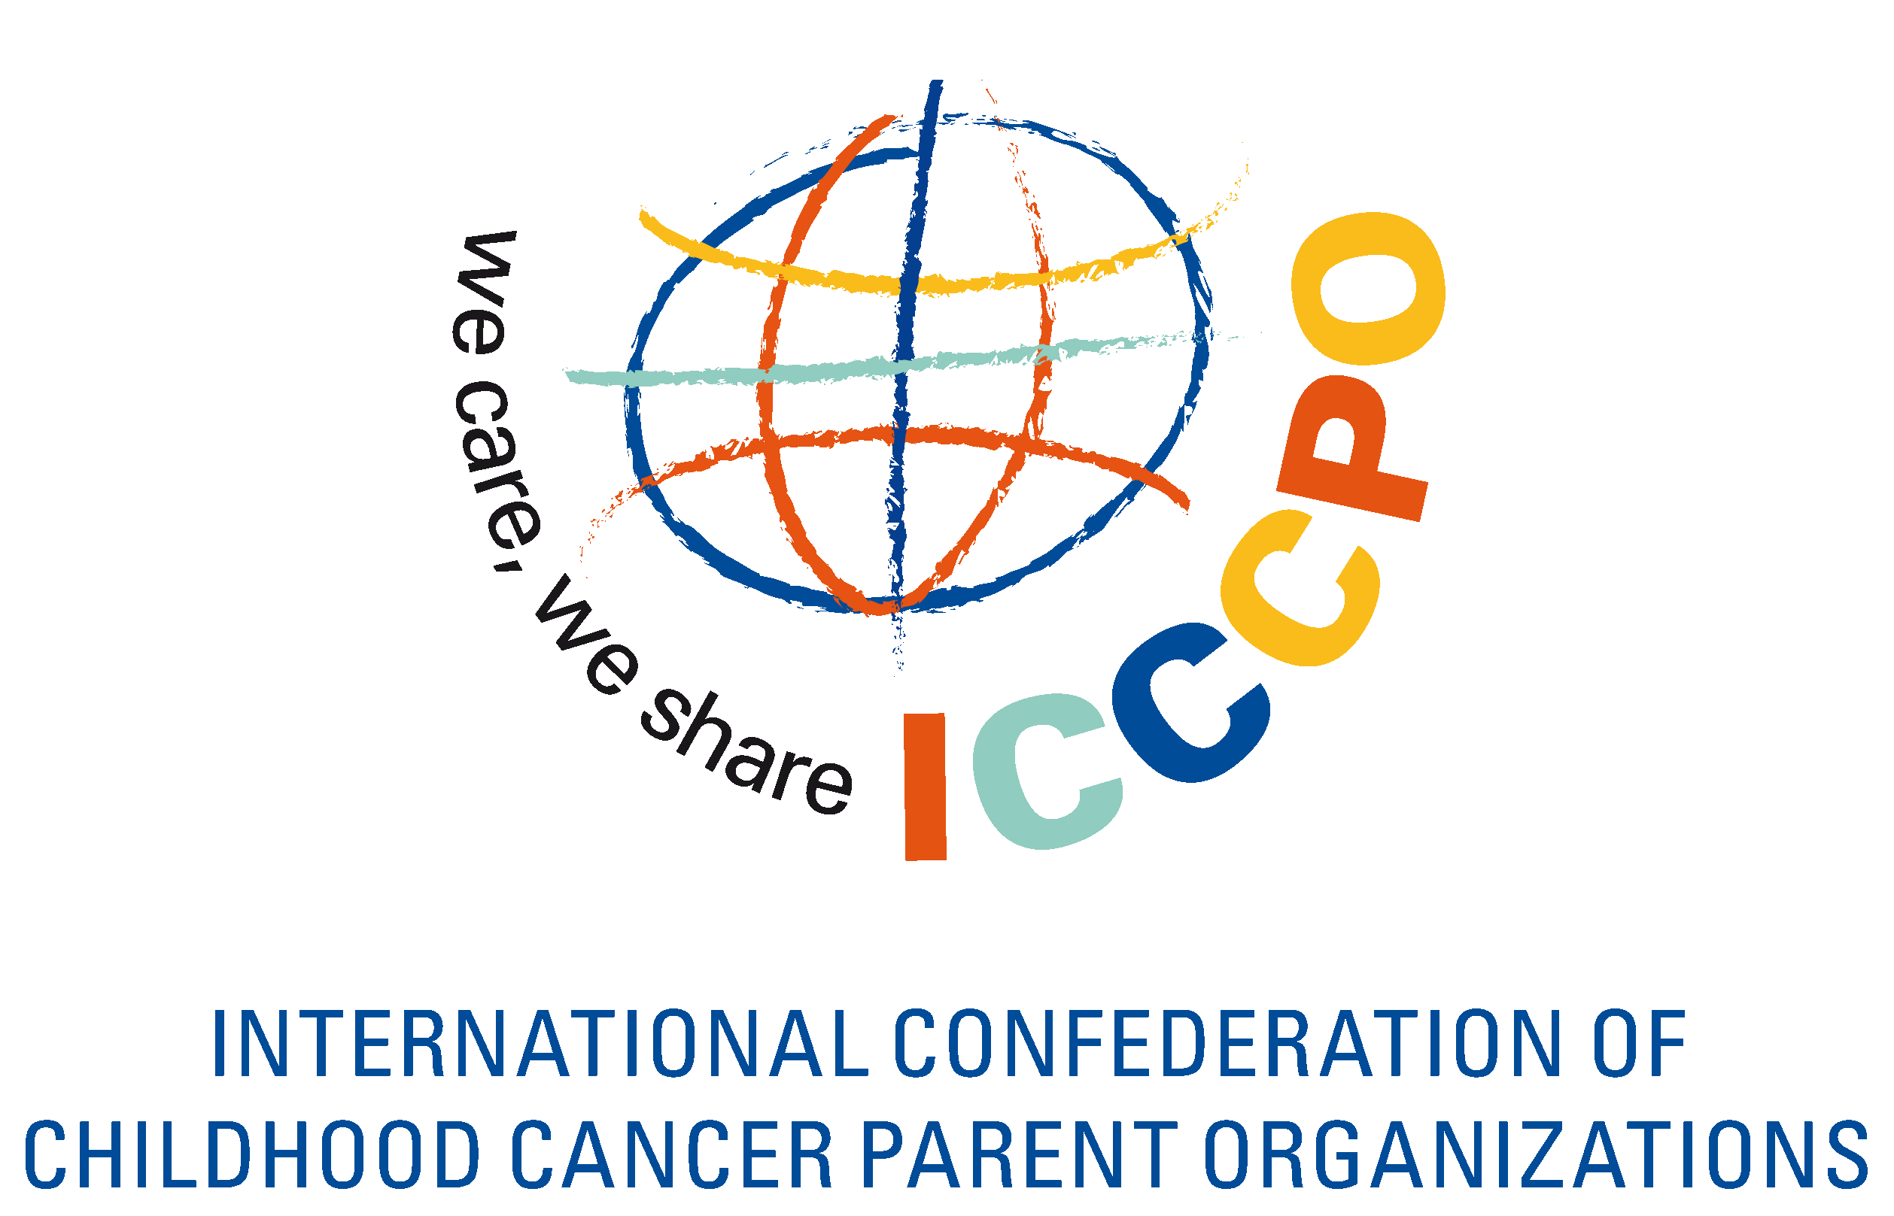

MEMBERSHIP APPLICATION FORM

Please send this Application Form by post or email to:

ICCCPO International Office
c/o Schouwstede 2b
3431 JB Nieuwegein
THE NETHERLANDS

Email: icccpo-secretariat@vokk.nl

Please attach:

- A Charter or Bylaws
- A list of Board members indicating if they are parent, survivor or sibling and paid staff (if any) and a brief biography of each
- A brochure describing your organization (not needed if you have a website)
- Your latest (audited) annual report, or if it is on your website add the link here:
…………………………….

If you have any questions, please contact Patty Brouwer at the ICCCPO International Office,
icccpo-secretariat@vokk.nl.

PLEASE NOTE: The application has to be fully completed and in English

1. Organization
name of organisation
short name organisation
name and position of contact person on website
name and position of second contact person
Address
Zipcode
Town
Country
Region
Website
Telephone
Fax
Email

2. Structure
Mission Statement
When was your organization founded?
How many board members does your organization have?
What is the composition of your board?
number of parents in board
number of family members in board
number of professionals in board
number of survivors in board
number of siblings in board
number of corporate members in board
number of others in board
How often does your board meet per year?
How many volunteers are involved in the activities and services of your organisation?
If you have membership, how many members does your organization have?
number of parents as members
number of family members as members
number of professionals as members
number of survivors as members
number of siblings as members
number of corporate members as members
number of others as members
How many local groups or chapters does your organization have?
What are the titles and roles of your paid staff?
total number of staff
number of paid/salaried staff full time
number of paid/salaried staff parttime
number of volunteer staff full time
number of volunteer staff part time
Do you have an own office or rented office? | YES NO
Do you have any sub-offices? how many

3. Services and programmes of organization  Please list the types of activities or services your organization provides | yes - what - how often
newsletter
magazine for young adults
magazine for children
website
written information (books, brochures)
audiovisual information (cd's, dvd's, video's)
digital information (cd-roms)
conferences
parents programmes
siblings programmes
childrens programmes
teenagers programmes
survivors group or programmes
grandparents programmes
bereaved parents programmes
bereaved siblings programmes
school programme and/or information for schools
parent house(s)
camps
other recreational programmes
involved in setting up treatment guidelines
training programmes for professionals
advocacy
direct medical or treatment assistance
provide funds to create a childhood cancer ward
provide funds for playrooms, play areas etc.
subsidize salaries of hospital staff
own a hospital or medical facility

Services and programmes of local chapters (only to be completed if you have local chapters) | yes - what - how often
newsletter
magazine for young adults
magazine for children
website
written information (books, brochures)
audiovisual information (cd's, dvd's, video's)
digital information (cd-roms)
conferences
parents programmes
siblings programmes
children’s programmes
teenagers programmes
survivors group or programmes
grandparents programmes
bereaved parents programmes
bereaved siblings programmes
school programme and/or information for schools
parent house(s)
camps
other recreational programmes
involved in setting up treatment guidelines
training programmes for professionals
advocacy
direct medical or treatment assistance
provide funds to create a childhood cancer ward
provide funds for playrooms, play areas etc.
subsidize salaries of hospital staff
own a hospital or medical facility

Area of work of organization | yes - where
local
provincial/regional
national
affiliation with hospital(s)* | which one
member of national organisation | which one
affiliation with national organisation | which one

International programmes of organization | yes with whom
twinning project and with whom
international support programme

4. Budget of organization
What is the annual budget of your organization in Euro?
Sources of funds | yes
membership fees
fund raising/donations
support from government
grants from public and private funds and trusts
sponsoring
sales of products, etc.
other sources of funding

NUMBER of children with cancer being assisted/provided IN 2012 | and total in the last 6 years (2006-2012)
2012: | 2006-2012:
Major breakthroughs as a result of advocacy initiatives: 2009-2013
1.
2.
3.
4.
5.
6.
7.
The ICCCPO membership fee is € 600 per year.

If your organisation does not have the financial means to pay € 600, there is a possibility for organisations with limited resources to apply for reduced fee.

Do you wish to apply for reduced membership fees? YES NO
(we will send you the form. Application for reduced fee has to be renewed every year)

Signature of Chairperson _________________________________________________

Date _________________________________________________________________
Name of Chairperson ____________________________________________________

Please attach:

- A Charter or Bylaws
- A list of Board members indicating if they are parent, survivor or sibling and paid staff (if any) and a brief biography of each
- A brochure describing your organization (not needed if you have a website)
- Your latest (audited) annual report, or if it is on your website add the link here:
…………………………….

Thank you for completing this application.
We look forward contacting you with the ICCCPO Board’s and AGA’s decision.

