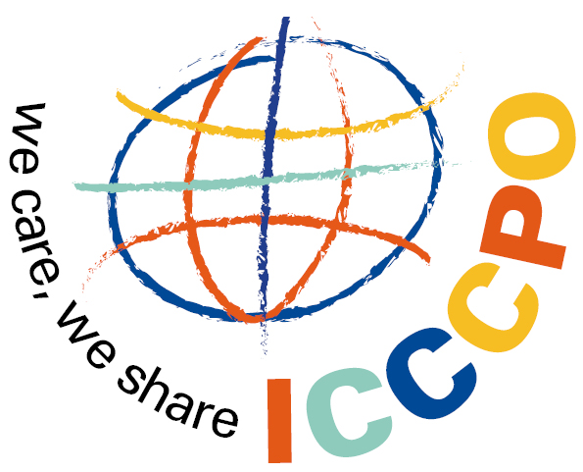

MEMBERSHIP APPLICATION FORM

Please send this Application Form to:

International Confederation of Childhood Cancer Parent Organizations
Schouwstede 2b
3431 JB Nieuwegein
THE NETHERLANDS

Phone: + 31 30 2422944
Fax: + 32 30 2422945
Email: icccpo-secretariat@vokk.nl

Please attach:

- A Charter or Bylaws
- A list of Board members and paid staff (if any) and a brief biography of each
- A brochure describing your organization (not needed if you have a website)
- Your latest annual report (not needed if it is on your website)

If you have any questions, please contact Patty Brouwer at the ICCCPO Secretariat, icccpo-secretariat@vokk.nl.

PLEASE NOTE: The application has to be completed in English.

I Organisation
Organization’s name ___________________________________________________________
_____________________________________________________________________________
Short name:

Address ______________________________________________________________________
Zip code ______________________________Town __________________________________
Country ______________________________________________________________________
Telephone ____________________________ Fax ____________________________________
Email ________________________________ Web Site ________________________________
Name of contact person __________________________________________________________
Position of contact person ________________________________________________________
Second contact person ___________________________________________________________

II Structure

Mission Statement _____________________________________________________________

_____________________________________________________________________________
When was your organization founded? ______________________________________________
How many board members does your organization have? _______________________________
What is the composition of your board?
parents ______ professionals ______ survivors ______
siblings ______ corporate members ______ others ______
How often does your board meet? _________________________________________________
How many volunteers are involved in the activities and services of your organisation? _______
If you have membership, how many members does your organization have?
parents ______ family members ______ survivors ______
professionals ______ general public ______ other ______
How many local groups or chapters does your organization have? ________________________

How many paid staff do you have? _________________________________________________
What are the titles and roles of your paid staff? _______________________________________
_____________________________________________________________________________
_____________________________________________________________________________
III Activities and services

Please list the types of activities or services your organization provides.
0 Parent support groups 0 Parent house 0 Support of bereaved families
0 Children’s activities 0 Camps, recreational programs

0 Siblings program 0 Survivors program 0 Conferences
0 Newsletter 0 Books and brochures 0 School program/information
0 Advocacy 0 Fundraising 0 Employment of hospital staff
Other: _______________________________________________________________________
_____________________________________________________________________________
What actives or services do your local chapters (if any) provide?
0 Parent support groups 0 Parent house 0 Support of bereaved families
0 Children’s activities 0 Camps, recreational programs

0 Siblings program 0 Survivors program 0 Conferences
0 Newsletter 0 Books and brochures 0 School program/information
0 Advocacy 0 Fundraising 0 Employment of hospital staff
Other: _______________________________________________________________________
_____________________________________________________________________________
Does your organization have an affiliation with a hospital? _____________________________

Do your local chapters (if any) have affiliations with hospitals? __________________________

IV Budget
What is the annual budget of your organization in Euro? _______________________________
What is your main source of funding? (i.e. Government grants, corporate donations, private donations)
_____________________________________________________________________________
The ICCCPO membership fee is € 500 per year.

If your organisation does not have the financial means to pay € 500 there is a possibility for organisations with limited resources to apply for a reduced fee.

Do you wish to apply for reduced membership fees? YES NO
(application for reduced fee has to be renewed every year)

Signature of Chairperson ____________________________________ Date ________________
Name of Chairperson ____________________________________________________________

Thank you of completing this application.
We look forward to contacting you with the ICCCPO Board’s and AGA’s decision.

